PULSE OXIMETRY VS TRANSCUTANEOUS MONITORING

Introduction
Non-invasive monitoring of oxygenation has become a standard procedure. Of the two methods available, namely transcutaneous partial pressure of oxygen (tcpO2) monitoring and pulse oximetry, the former is currently at risk of being replaced by the latter.
This is despite the fact that both methods provide substantially different information about oxygenation and are particularly helpful if used in combination.

Transcutaneous partial pressure of oxygen (TCPO2) monitoring
Principle of operation
TCpO2 electrodes measure the partial pressure of oxygen through the skin. They consist of a platinum cathode and silver reference anode, encased in an electrolyte solution and separated from the skin by an O₂-permeable membrane.
Electrodes are heated to improve oxygen diffusion and to arterialize the capillary blood. Oxygen is reduced at the cathode, generating an electric current proportional to the O₂ concentration in the capillary bed underneath the sensor.
Sensors require a 10-15 min warm-up period after application and have to be calibrated every 4-8hours.
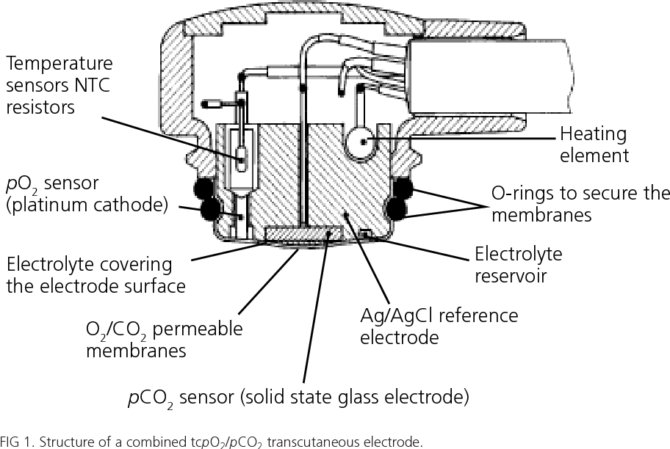

Factors influencing measurements
The agreement between arterial and skin-surface PO2 depends on a fragile balance between factors that increase the PO2, namely a shift to the right of the oxygen dissociation curve, and a decreased O2 solubility in blood, both of which are caused by the heating of the skin, and factors which decrease PO2, namely the oxygen consumption in the heated skin and inside the electrode.
Thus, transcutaneous (TCpO2) and arterial (PO2(aB)) represent two different measurements, and at times changes in TCpO2 are more important than the actual values measured.
In hemodynamically unstable children, TcpO2 will reflect changes in the circulatory status and thereby give an early warning of the onset of circulatory compromise.

Sensor Temperature
There is good agreement with arterial PO2 (PO (aB)) only at 44 °C, but then frequent (every 2-4hours) resetting is necessary. At lower sensor temperatures, TCPO2 will under read PO2 (aB), with the difference becoming larger with increasing PO2 (aB).
This is particularly important in preterm neonates, in whom high PO2 (aB) levels must be reliably detected to minimize the risk of retinopathy of prematurity.
Probe placement
TCPO2 will under read PO2 (aB) if the sensor is placed on a bony surface, if pressure is applied on the sensor, or if too much contact gel is used.
With patent ductus arteriosus and right-to-left shunt, TCPO2 will be higher on the upper than on the lower half of the thorax.
In infants with a closed arterial duct, the electrode should ideally be placed on the lower back or abdomen, or on a thigh.

Peripheral perfusion
TCPO2 depends on skin perfusion. If the latter is reduced, e.g. due to hypotension, anemia, acidosis (pH < 7.05), hypothermia, or marked skin edema, TCPO2 will be accordingly low.
If an under reading of PO2 (aB) occurs, it is advisable to check the patient for these conditions.
Skin thickness
Close agreement with PO2 (aB) can only be found in neonates. This does not imply, however, that t TCPO2 monitors can only be used in this age group.
Studies in children and adults did in fact show that the ratio between TCPO2 and PO2 (aB) is extremely constant in these patients (independent of age and PO2 (aB)), it merely is 20 % lower than in neonates, i.e. approximately 0.8.
Detection of hypoxemia and hyperoxemia
Under optimal measurement conditions, TCPO2 can be expected to be within ±9.8-15 mmHg/1.3-2.0kPa of PO2 (aB) 95 % of the time.
Clinically, however, it seems more important to know whether the TCPO2 monitor will reliably detect all situations where a patient has either too little (e.g. < 40mmHg/5.3 kPa) or too much oxygen (> 80 mmHg/10.7 kPa).
In this regard, the data available suggest that approximately 15 % of both hypoxemic and hyperoxemic instances are missed by TCPO2 monitors, whereas their specificity, particularly with regard to hypoxemia, is somewhat higher.

PULSE OXIMETER (TRANSCUTANEOUS ARTERIAL OXYGEN SATURATION MONITORING)
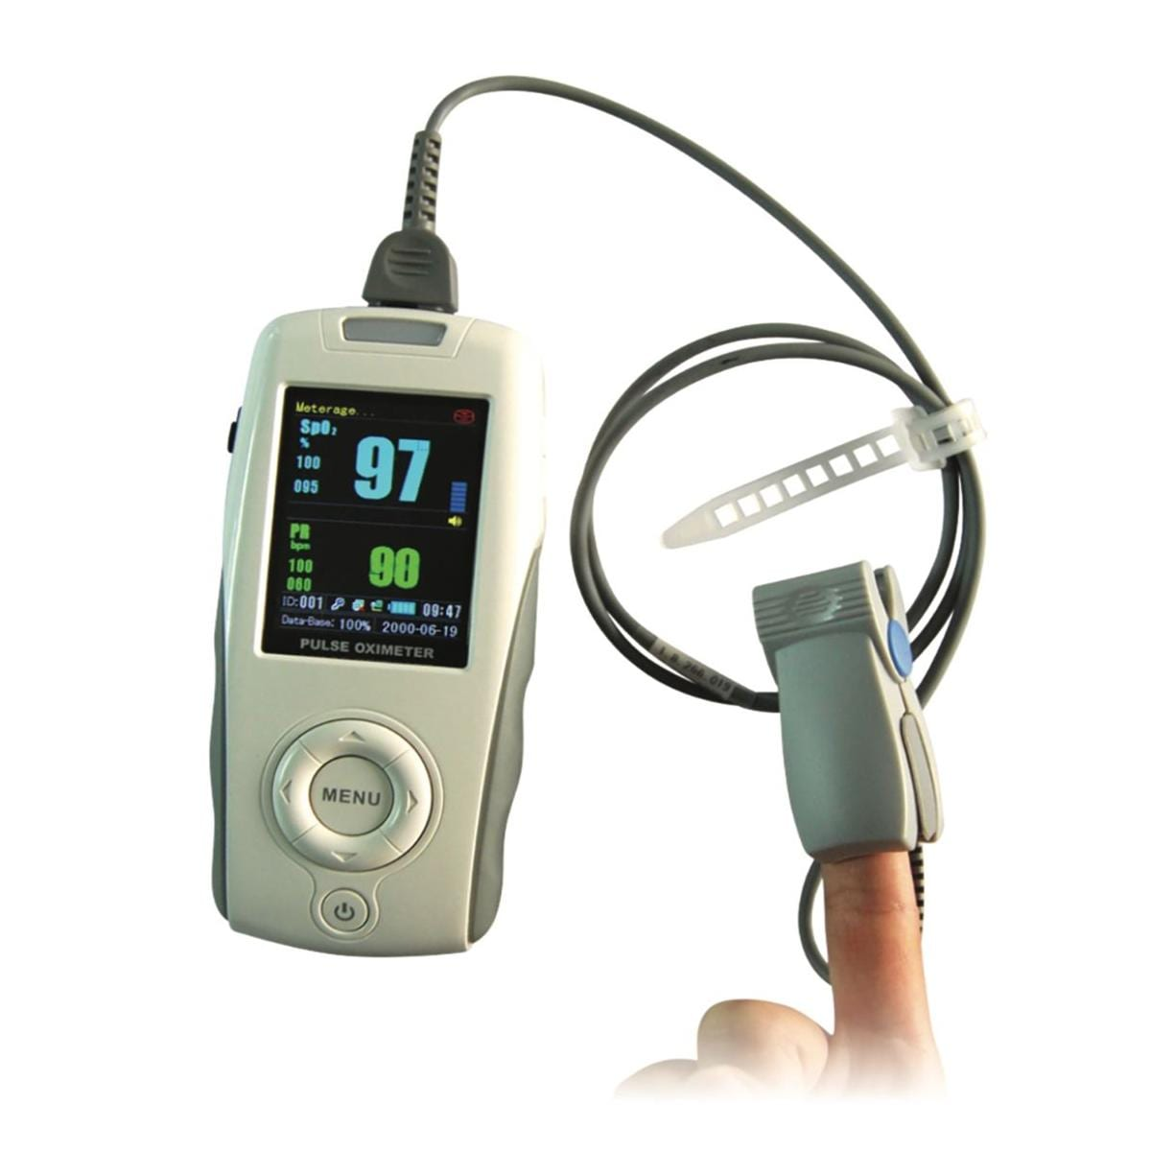

Introduction
Pulse oximetry is based on the concept that arterial oxygen saturation determinations can be made using two wavelengths, provided the measurements are made on the pulsatile part of the waveform.
The two wavelengths assume that only two absorbers are present; namely oxyhaemoglobin (HbO2) and reduced haemoglobin (Hb). These observations, proven by clinical experience, are based on the following:
- Light passing through the ear or finger will be absorbed by skin pigments, tissue, cartilage, bone, arterial blood, venous blood.
- ii) The absorbance’s are additive and obey the Beer-Lambert law: A = – logT = log lo/I = eD C
Where Io and I are incident and transmitted light intensities, e is the extinction coefficient, D is the depth of the absorbing layer and C is concentration.
iii) Most of the absorbance’s are fixed and do not change with time. Even blood in the capillaries and veins under steady state metabolic circumstances is constant in composition and flow, at least over short periods of time.
iv) Only the blood flow in the arteries and arterioles is pulsatile. Therefore, only measuring the changing signal, measures only the absorbance due to arterial blood and makes possible the determination of arterial oxygen saturation (SaO2). This is uninfluenced by all the other absorbers which are simply part of the constant background signal.
Construction and working
A pulse oximeter consists of a peripheral probe, together with signal conditioner, a microprocessor unit, display of a waveform, the oxygen saturation and the pulse rate.
Most oximeters also have an audible pulse tone, the pitch of which is proportional to the oxygen saturation. This is useful indication when one cannot see the oximeter display.
A typical pulse oximeter probe has two LEDs (light emitting diodes), one that transmits infrared light at a wavelength of approximately 940 nm and the other transmitting light at approximately 660 nm. The absorption of these select wavelengths of light through living tissues is significantly different for oxygenated haemoglobin (HbO2) and reduced haemoglobin (Hb).
The absorption of these selected wavelengths of light passing through living tissue is measured with a photo sensor.
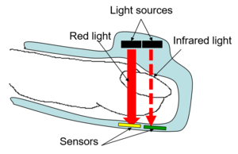
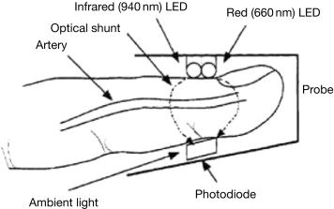
The red and infrared LEDs within the probe are driven in different ways, depending on the manufacturer. Most probes have a single photo detector (PIN-diode), so the light sources are generally sequenced on and off. A typical pulsing scheme of the LEDs is shown in Fig. 9.7.
To compensate for ambient light during the time when both LEDs are off, the light level is measured and then subtracted from each light channel between cycles. This minimizes the effects due to ambient conditions which may vary during monitoring.
Depending on the make and model of pulse oximeters, the drive currents of LEDs, pulse widths, off and on cycles between pulses and cycle times can all vary.
The output of the photodiode has a raw signal represented in Fig. 9.8. There will be one signal that represents the absorption of red light (660 nm) and one that represents infrared light (940nm).
The ac signal is due to the pulsing of arterial blood while the dc signal is due to all the nonpulsing absorbers in the tissue. Oxygen saturation is estimated from the ratio (R) of pulse-added red absorbance at 660 nm to the pulse-added infrared absorbances at 940 nm.
$$R=\frac{\frac{AC660}{DC 660}}{\frac{AC940}{DC 940}}$$

The microcontroller in a pulse oximeter can select out the absorbance of the pulsatile fraction of blood, i.e. that due to arterial blood, from constant absorbance due to non-pulsatile venous or capillary blood and other tissue pigments.
OR
Pulse oximeters do not measure the concentration of oxygen dissolved in plasma but the proportion of hemoglobin molecules in arterial blood that are loaded with oxygen. Deoxygenated hemoglobin absorbs more light in the red band (at 600-750 nm), i.e. it looks less red, whereas oxygenated hemoglobin absorbs more light in the infrared band (850-1000 nm).
The ratio of the absorbance of red and infrared light sent through a tissue correlates with the proportion of oxygenated to deoxygenated hemoglobin in the tissue.
Conventional pulse oximeters determine the arterial component within this absorbance by identifying the peaks and troughs in the absorbance over time; thereby obtaining a "pulse-added" absorbance that is independent of the absorbance characteristics of the non-pulsating parts of the tissue.
These pulse-added light absorbances are then associated algorithmically with empirically determined arterial oxygen saturation (SO2(aB)) values.
When the light absorption at the trough (which should include all the constant absorbers) is subtracted from the light absorption at the peak then, in theory, the resultants are the absorption characteristics due to added volume of arterial blood only.
A typical block diagram for a pulse oximeter
Fig. 9.9 shows a typical block diagram for a pulse oximeter.
There are a number of operational amplifiers in the circuit which are used to convert current to voltage (I to V), drive an ADC (analog-to-digital converter), drive LED excitation sources, buffer a microprocessor input, and process audio.
The pulse oximetry light is provided by two light emitting diodes (LED). A red LED emits light in the 600-nm (nanometer) to 700-nm region, while an IR LED emits in the 800-nm to 900-nm region.
The two LEDs are switched on and off at a high rate by the current sources formed by U1 and U2. The transmitted or reflected light is detected by photodiode D3, which produces a small current proportional to the light detected. This current is converted to a voltage via a precision FET-input op amp that is typically used in photodiode detectors or current-to-voltage converters.
FET-input op amps require very little input bias current, ensuring that the majority of the photodiode current passes through the feedback resistor, giving high accuracy.
U1 and U2, precision micro power op amps, form the heart of the current sources that drive the red and IR LEDs. The two LEDs require different currents, so a dual op amp is used.
The voltage from the DAC (digital-to-analog converter) is fed to U1 and U2 via analog switch, SW1. The op amps have limited output current capability; therefore external FET transistors (Q1 and Q2) are used.
The voltage across RISET1 and RISET2 sets the current through the LEDs.
The output of the I-to-V converter is then filtered, and the signal is then fed to a buffer op amp, which interfaces to the microprocessor to indicate a no-connection fault if the pulse oximeter falls off the patient.
The signal is also fed to ADC driver U5, which sets the signal to the appropriate amplitude and offset settings, which are compatible with the ADC. Depending on the system requirements, the ADC driver can be realized with traditional op amps or a differential amplifier.
The signal is then digitized and analyzed by the microprocessor. The op amp U6 provides the drive signal to a speaker or transducer for audible monitoring purposes.
Because of the high level of analog integration, the implementation of a single chip portable pulse oximeter using the ultra-low power capability has become possible with the availability of MSP430, from M/s Texas Instruments, keeping the external components to a minimum.
M/s Analog Devices have also introduced Precision Analog Microcontroller family of products–AduC7024—which includes the key analog building blocks required by high-end oximetry design. This chip also includes a high-performance, high-speed multi-channel 12-bit ADC and 2DACs. These features allow recovery of the weak arterial pulsatile signals generally seen during low peripheral blood circulation. The Micro Converter also includes a 32-bit ARM7TDMI core. Running at 41.8 MHz, it provides a very powerful computational platform.
A proprietary digital signal processing algorithm, detects arterial blood pulsations, detects and rejects motion artifacts, calculates SpO2 and heart rate values, and filters and scales the real time arterial blood pulsatile waveform (plethysmogram). Additional functions of the CPU include control of the graphics LCD display, generating audio pulse tones via the onboard PWM, etc.
A limitation of the pulse oximeter is that ambient lights have been shown to interfere with the measurement. Therefore, covering the cuff with an opaque material is necessary to prevent such interference. Motion artifact is also a potential problem. This is because the information containing pulse activity is in the same frequency range as motion artifact.
Several recent advances in microcontroller technology have reduced the effects of interference on pulse oximeter function. Time division multiplexing, whereby the LED’s are cycled: red on, then infrared on, then both off, many times per second, helps to eliminate background ‘noise’.
Quadrature division multiplexing is a further advance in which the red and infrared signals are separated in phase rather than time and then recombined in phase later. In this way, an artifact due to motion or electromagnetic interference may be eliminated since it will be in the same phase of the two LED signals once they are recombined.
Pulse oximeters are available as both mains supply powered and those which work on batteries. Fingertip models have also become available which combine the sensor, electronics and batteries.

Factors influencing measurements
Pulse oximeters are easier to use than TCpO2 monitors: they do not require calibration or heating of the skin and provide immediate information about arterial oxygenation.
However, it is probably because of this apparent ease of use that potentially erroneous measurements on a pulse oximeter are more at risk of being overlooked than those occurring with a TCpO2 monitor.
A thorough understanding of the factors potentially affecting the precision of a pulse oximeter is therefore particularly important.
- Probe placement
The light-receiving diode must be placed exactly opposite the emitting diode, and both must be shielded against ambient light and not be applied with too much pressure.
Light bypassing the tissue can cause both falsely high and falsely low values. The sensor site must be checked after every 6-8 hours.
High pressures may result in a reduced signal-to-noise ratio and may thus severely impair the precision of the SO2 (P) measurements. Highly flexible sensors provide better skin contact and thus better signal-to-noise ratio.
- Peripheral perfusion
Conventional oximeters require a pulse pressure above 20 mmHg/2.7 kPa or a systolic blood pressure above 30 mmHg/4 kPa to operate reliably.
Because next-generation oximeters rely less on pulse detection, they continue to operate even at lower blood pressure levels.

- Response times
In theory, the response time of a pulse oximeter depends only on the time it takes for the blood to travel from the lung to the sensor site, which is 3-4 sec in neonates.
However, all pulse oximeters currently available average their values over 2-15 sec to level out any erroneous measurement which may occasionally occur even under optimal conditions. This averaging, however, has unwanted consequences:
- It delays the response to a true fall in SO2 (P) values
- It may lead to a mixing up of true with falsely low SO2 (P) readings during periods of intermittent body movements (e.g. during feeding), which can result in the erroneous impression that the patient suffers episodes of prolonged hypoxemia.
- It can lead to erroneous conclusions in situations where a precise measurement of SO2 (P) is required, e.g. during sleep studies.
- It hinders the definition of normal ranges for the frequency and severity of intermittent falls in SO2 (P) in infants or children, since such data would only be valid for the specific averaging mode with which they have been obtained. This is particularly true for the next-generation instruments, which use variable averaging times depending on measurement conditions, i.e. 2-4 sec averaging under optimal conditions, and up to 15 sec averaging during periods of motion.
- Motion artifact
The pulsatile (arterial) component contributes less than 1 % to the total absorbance measured by the pulse oximeter. Hence, at least conventional pulse oximetry is very sensitive to sudden changes in background signal, e.g. due to body movements.
With conventional oximeters, identification of motion artifact is best done by displaying the light plethysmographic waveforms. Whenever these are distorted, SPO2 readings become unreliable.
Alternatively, the pulse rate can be compared with the heart rate from an ECG monitor, which should be identical.

- Other hemoglobins and pigments
Methemoglobin (MetHb) will cause SPO2 readings to tend towards 85 %, independent of SPO2 (aB).Carboxyhemoglobin (COHb) will cause overestimation of SPO2 (aB) by 1 % for each percent COHb in the blood.
Fetal hemoglobin (HbF) and bilirubin do not affect pulse oximeters but may lead to a bias on SPO2 (aB) by CO-oximeters. In patients with dark skin, SPO2 values may be falsely high, particularly during hypoxemia.
- Algorithms
Pulse oximeters, in contrast to CO2 -oximeters, do not measure O2 saturation but derive their values from a "look-up" table which is based on empirical data from healthy adults.
These may vary between brands and even between different software versions from the same manufacturer. Also, some instruments subtract a priori the typical levels of COHb, MetHb, etc. in healthy non-smoking adults from their measurements and will thus display SPO2 values that are some 2-3 % lower than those displayed by other instruments.
This approach, i.e. to display the so-called "fractional" SPO2 instead of the usual "functional" SPO2 has largely been abandoned in recent years, probably because it resulted in an unacceptably poor ability of instruments using this approach to detect hyperoxemia.

